step1:visit to NCBI Website<https://www.ncbi.nlm.nih.gov/>

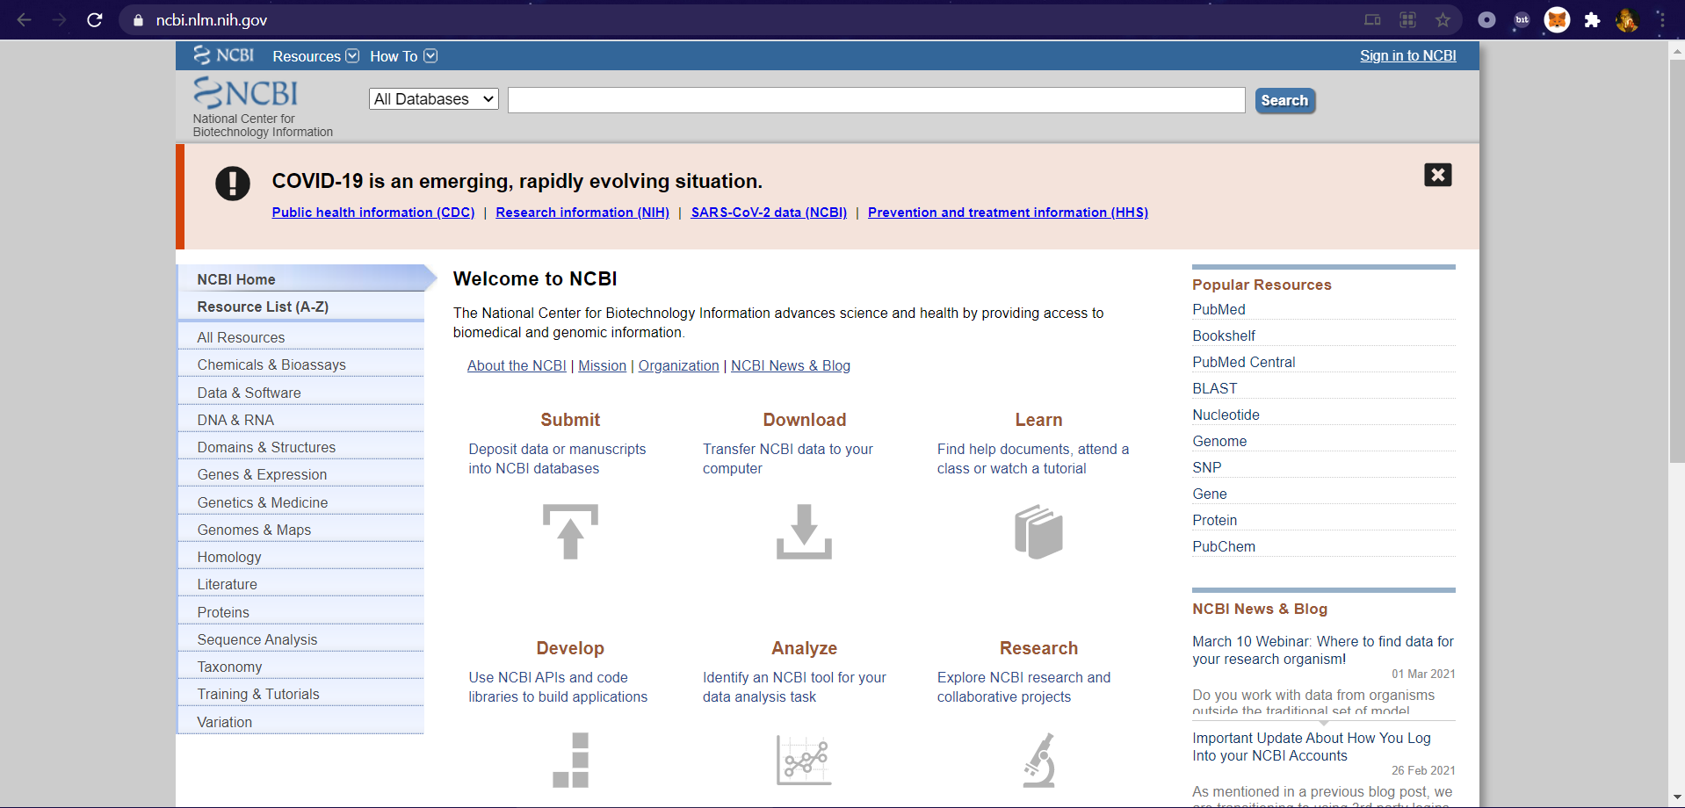

Step2:Select Database as “Nucleotide” and Virus as “H1N1”

Click Enter.

Step 3:Click on ”FASTA” from [Nicotiana benthamiana **H1N1** gene, promoter region](https://www.ncbi.nlm.nih.gov/nuccore/KP747648.1)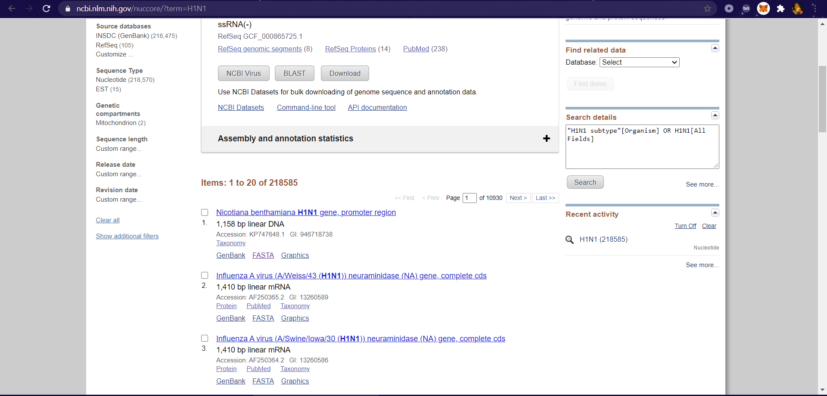

A sequence like this will be diaplayed copy the Sequence and Paste it in a .txt file.

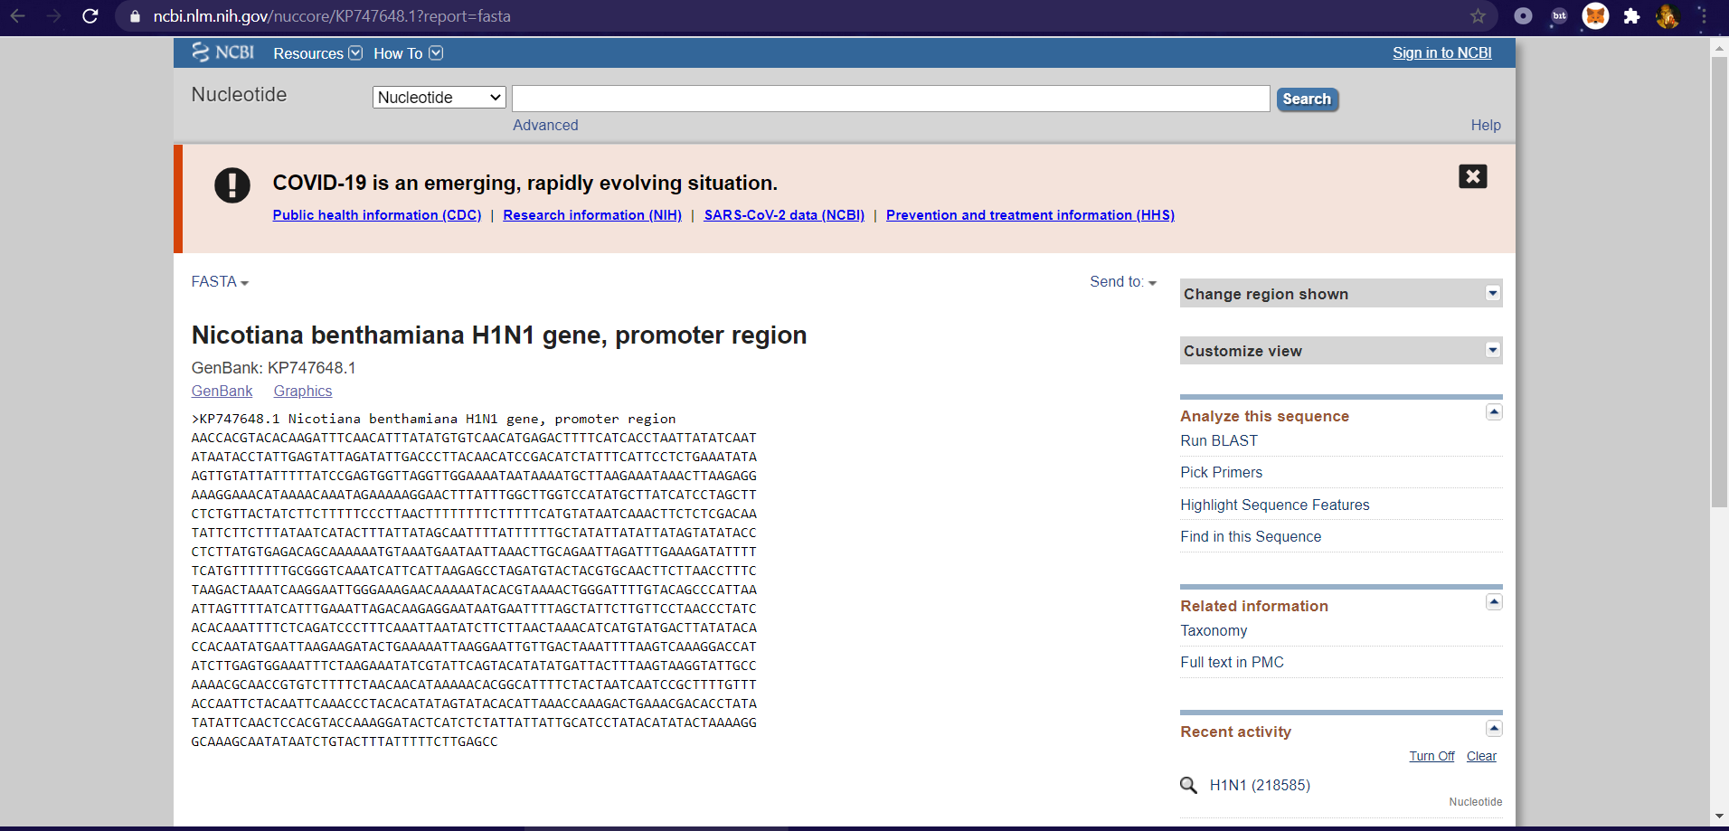

Step 4:Click on Run BLAST on Right side.

Following Window will be displayed

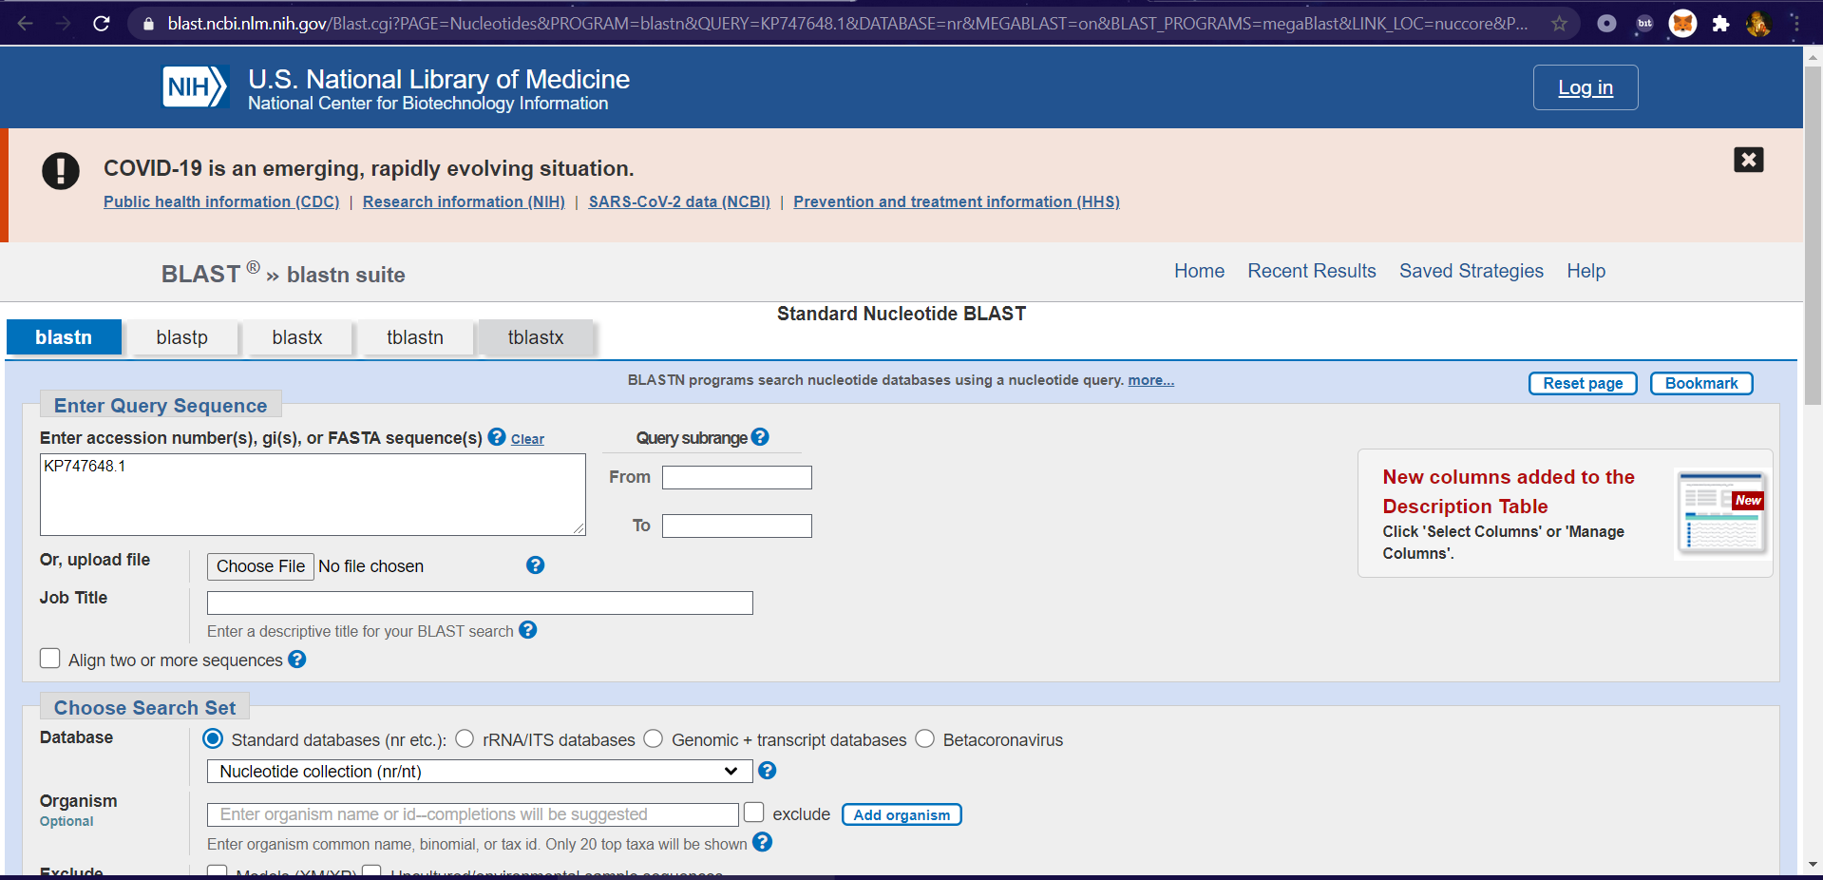

Step 5: Choose.txt file & Click on Blast.

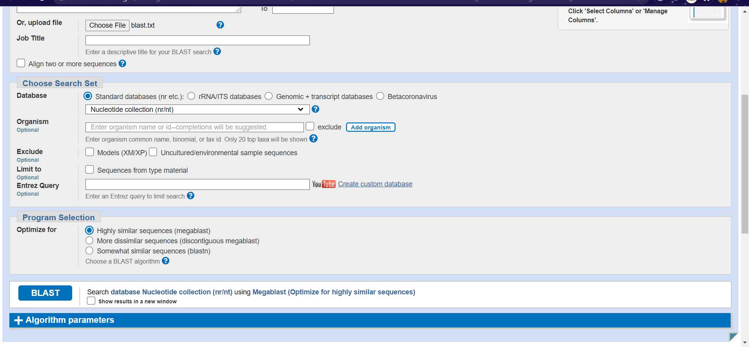

We can see Alignments as below :

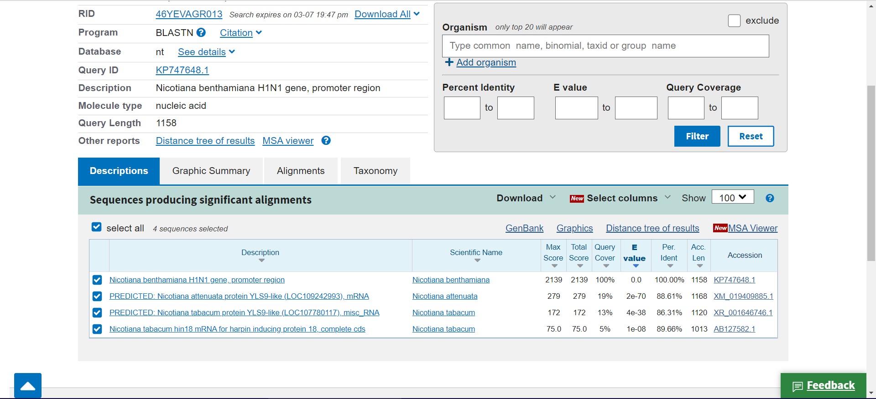

Select any 1 Alignment(Selecting: [Nicotiana benthamiana H1N1 gene, promoter region](https://blast.ncbi.nlm.nih.gov/Blast.cgi#alnHdr_946718738))

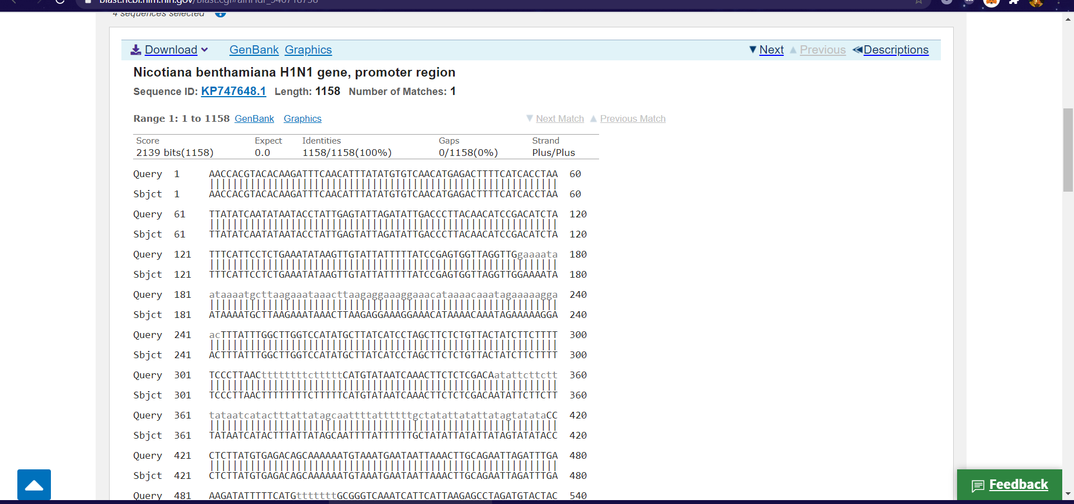

Done.

AIM: Perform BLAST Search on a Specific gene Sequence of a Specific Organism

file=open("Blast 5.txt","r")

r=file.read()

size=len(r)

score_A=0

score_C=0

score_T=0

score_G=0

for i in range(size):

if(r[i]=='A'):

score_A+=1

elif (r[i]=='C'):

score_C+=1

elif (r[i]=='T'):

score_T+=1

elif (r[i]=='G'):

score_G+=1

print("score of A is ",score_A)

print("score of C is ",score_C)

print("score of T is ",score_T)

print("score of G is ",score_G)

OUTPUT : -

score of A is 415

score of C is 201

score of T is 406

score of G is 136